DEPARTMENT OF COMPUTER SCIENCE AND ENGINEERING

CSA0503-DATABASE MANAGEMENT SYSTEMS
DDL Commands – CREATE, ALTER, DROP
EXPERIMENT - 1
AIM:
To Create, Alter, Drop, Rename, Truncate using Data Definition Language (DDL) statements.

Questions:
1) Create a table name STUDENT with following structure.
# Column Name Description Data Type
1 RegNo Registration Number NUMBER(3)
2 Name Student Name VARCHAR(15)
3 Gender Gender of the student CHAR(1)
4 DOB Date of Birth DATE
5 MobileNo Mobile Number NUMBER(10)
6 City Location of stay VARCHAR(15)

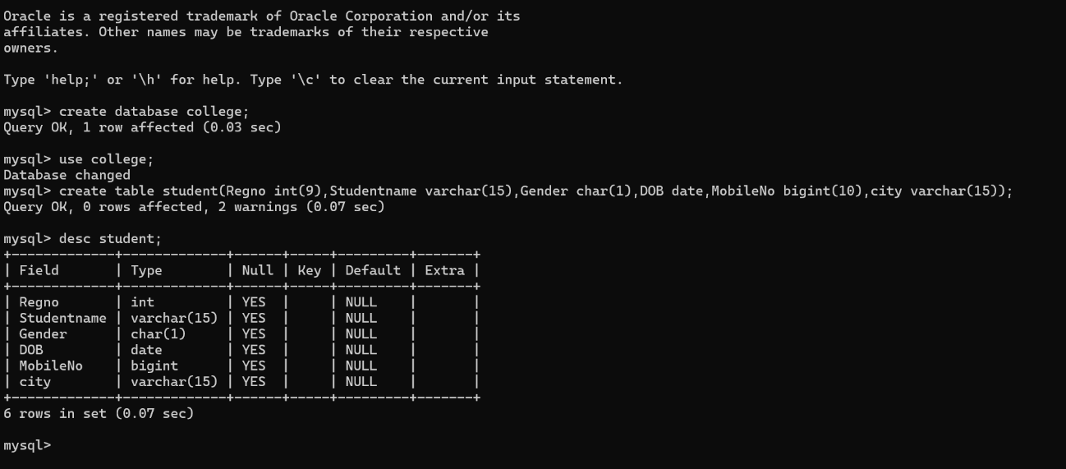
OUTPUTS:
1.

2.delete a column in student table
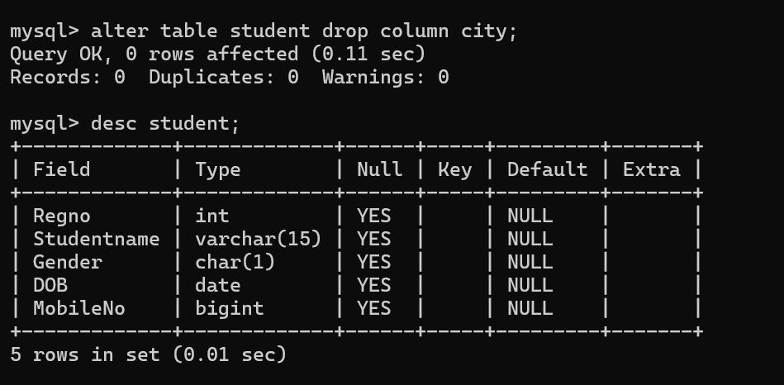
3. add a column in a student table
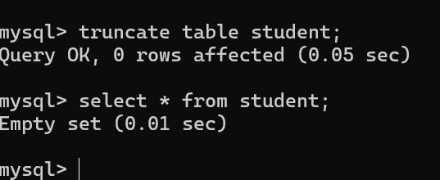
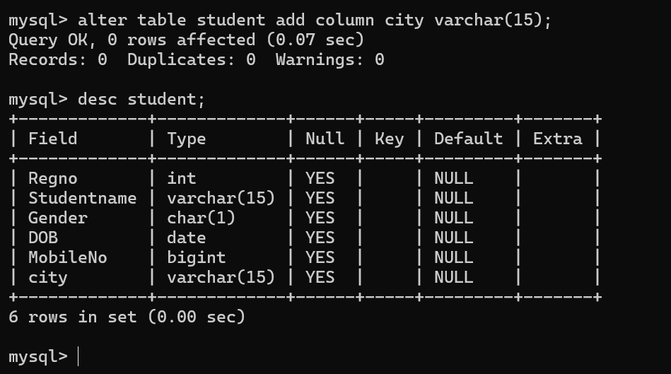
4.TRUNCATE TABLE of student

5) Create a table name FACULTY with following structure.

#
Column
Name Description Data Type
1FacNo Faculty Identifier VARCHAR(4)
2FacName Faculty Name VARCHAR(15)
3Gender Gender of faculty CHAR(1)
4DOB Date of Birth DATE
5DOJ Date of Join DATE
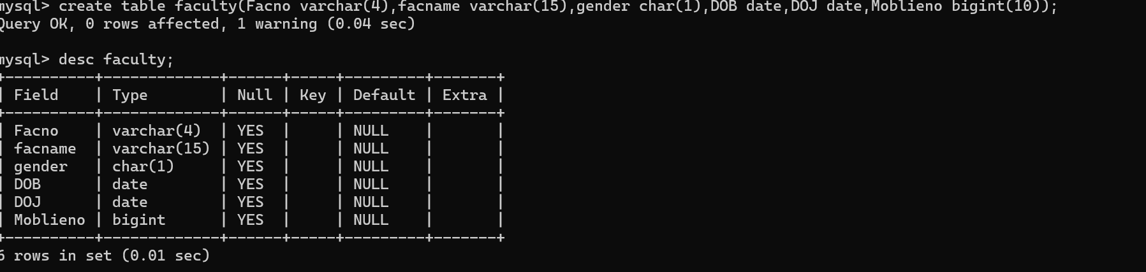
6MobileNo Mobile Number NUMBER(10)

6) Create a table name DEPARTMENT with following structure.

#
Column
Name Description Data Type
1DeptNo Department Identifier VARCHAR(4)
2DeptName Department Name VARCHAR(15)
3DeptHead Department Head VARCHAR(4)

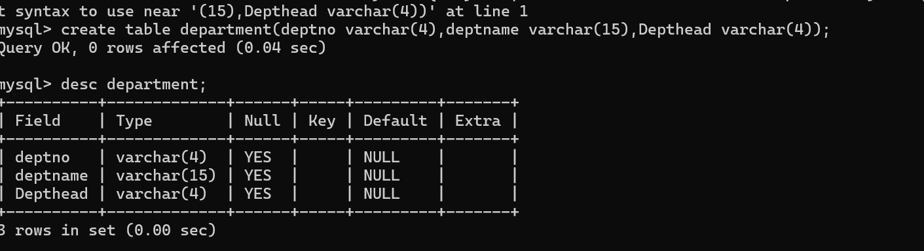
7) Create a table name COURSE with following structure.

#
Column
Name Description Data Type
1CourseNo Course Identifier VARCHAR(3)
2CourseDesc
Course
Description VARCHAR(14)
3CourseType Course Type CHAR(1)
4SemNo Semester Number CHAR(1)
5HallNo Hall Number VARCHAR(4)
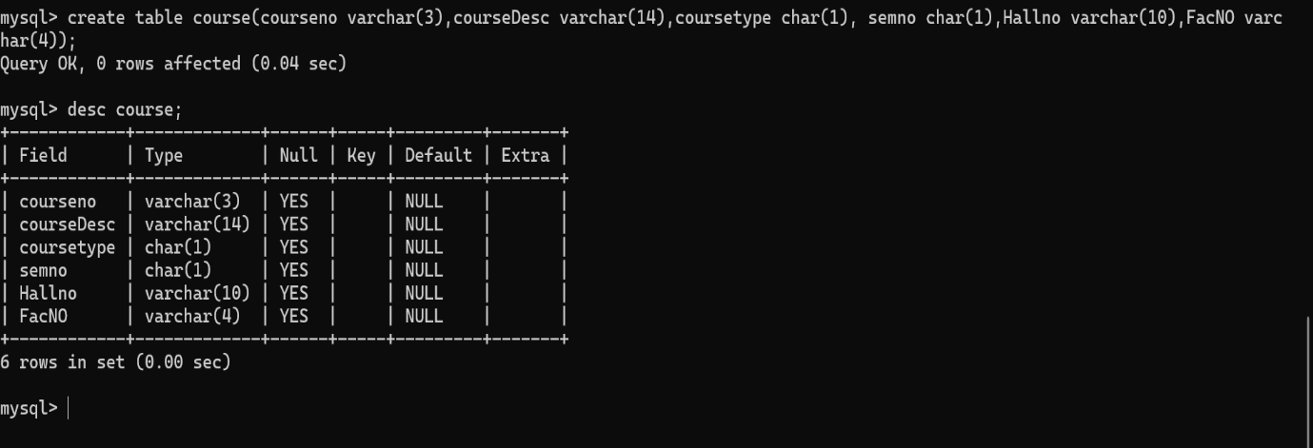
6FacNo Faculty Identifier VARCHAR(4)

8)Modify the table FACULTY by adding a column name Dept of datatype VARCHAR(10)
